Exercise: Klotski

You can look up anything online that you want that you think will help and discuss it with other interns. You can ask Uncle Edward for help as he wrote this program 23 years ago. It will take at least 2 weeks (80 hours) to complete it.

Difficulty level: 5 out of 5

The game only needs one player which will be the computer.

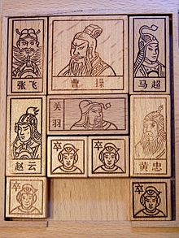

You start with the game board looking like the picture above. The goal is for the largest block to be moved to the bottom middle location so that it can be slid over the border. You want the computer to be able to do this in the least numbers of steps possible. You can name the blocks A to J since there are 10 of them or whatever you wish to name it.

To make a move, you can slide one block in any one direction (left, right, up, or down). For example, in the picture, you can slide the bottom left block to the right 1 space or right 2 spaces. Obviously this is hard because the blocks are different sizes as seen in the picture above. In the output, it must list all steps that the blocks take (like what direction it moves in and to what position).

The world record for the least number of steps to win the game is 59 steps. Uncle Edward can only program the computer to win in 86 steps. It’s minus 1% for every additional step greater than 59 so Uncle Edward only gets 73% on this exercise.